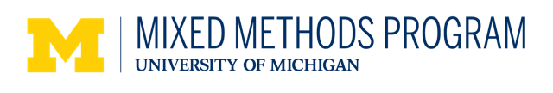

Application Form

University of Michigan Mixed Methods Program

U.S.-based Student Workshop Scholarship Awards

This award covers the registration fees for up to two doctoral students enrolled in a U.S.-based doctoral program to attend one of the University of Michigan Mixed Methods Program workshops.

Eligibility
Anyone who is enrolled in a doctoral program at a U.S.-based schools

Personal Information
Your name:
Address or contact information:
Email address:
Department:
University:
Current Degree Objective:
Workshop you wish to attend:

Personal Statement of Interest
Please submit a 1/2 page personal statement that describes pertinent personal experiences and goals that would make you an appropriate candidate for this award. Be sure to address:
a. Why you want to come to the workshop
b. Your background in quantitative research
c. Your background in qualitative research
d. Your background in mixed methods research
e. Your financial need for the scholarship

Research Project Statement
Please submit a ½ page research project statement that includes:
a. A draft title for your research project
b. The problem being addressed in your project
c. The types of quantitative and qualitative data that you will collect
d. The purpose of your study (for example, a dissertation project, a university project, etc.)

Additional Information Needed
Please submit:
- a letter of recommendation from your supervisor outlining how you would benefit from attending the workshop
- a letter/certificate indicating proof of student status from your university.
Please submit your application materials by email to Project Manager, Satoko Motohara at smotohar@umich.edu

Application Deadline
“Writing Your Mixed Methods Research for Publication” workshop (May 9 & 10, 2019)
Apply by April 4, 2019

“Designing and Conducting a Mixed Methods Dissertation or Thesis” workshop (June 19-21, 2019)
Apply by April 24, 2019

